

Project submitted in the context of the course   
Info3301 **Software Engineering**

**Developed By   
Jad Mrad  
George Raed**



Lebanese University

Faculty of Sciences I

Department of computer Sciences

2017 - 2018

# Acknowledgements

If any…

# Abstract

The chosen application/domain and the major steps done while achieving the project

# Table of Contents

Acknowledgements 2

Abstract 3

Table of Contents 4

Table of Figures 5

Table of Tables 6

Chapter I - Introduction 7

I.1. The business domain 7

I.2. About the modeled application 7

2.1. Users Persona 8

2.2. Analysis of the Existing Similar Programs 8

I.3. Plan of the document 8

# Table of Figures

Figure 1 Programming Language Market Shares - Early 2018 7

# Table of Tables

Table 1 Comparison of Existing Similar Programs & Frameworks 8

1. Introduction
   1. The business domain

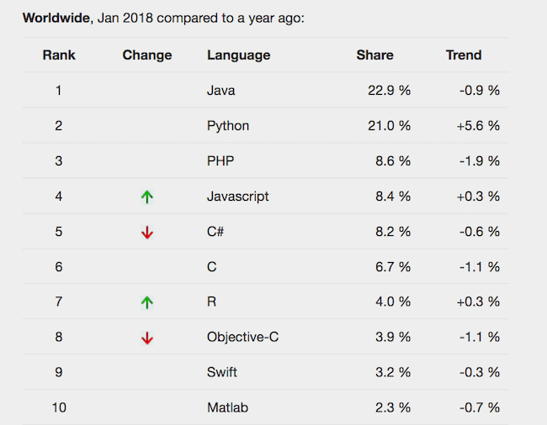This project fits into the software development domain and is specifically directed towards Java programmers working on JavaFx or GUIs in general. We believe this is an ideal community to target as it is sizable with 3 Billion devices running java and its sizable market hare at 22.9% as can be seen in figure 1. We also chose JavaFx as a platform to build upon as it is the most recent officially released framework for creating graphical user interfaces with updates coming frequently and as recent as 2 hours[1] before this report was written.

Figure 1 Programming Language Market Shares - Early 2018

* 1. About the modeled application

The program is intended to be used by anyone from beginners to experienced developers to design and implement JavaFx completely code-free. It can also be utilized by anyone who doesn’t know how to code which is useful on clients during the requirement gathering stage. With many more possibilities, the community needs such a code-free program not to mention the blueprints system that is so far unseen for JavaFx.

* + 1. Users Persona

Some key cases where our product would be optimal:

* Java developers creating GUI assets
* Newcomers to JavaFx that wish to explore its potential
* Clients to show Software Engineers what they want
* Swing users switching over to JavaFx syntax
  + 1. Analysis of the Existing Similar Programs

There are quite a few programs and frameworks that could be considered alternatives or competitors to ours yet none of them carry the functionalities that EasyFx provides, mainly the handler management blueprints.

|  |  |  |  |  |
| --- | --- | --- | --- | --- |
|  | Last Update | Up to Java version | Visual Coding (Drag & Drop) | Blueprints |
| Oracle Scene Builder 1.1 |  | Java 7 | No | No |
| Oracle Scene Builder 2.0 | April 2014[2] | Java 8 | No | No |
| Gluon Scene Builder |  | Java 10 | Yes | No |
| EasyFx | January 2019 | Java 10 | Yes | Yes |

Table 1 Comparison of Existing Similar Programs & Frameworks

* 1. Plan of the document

In this document, we propose a specification, design and project planning for an Abc XyZ application. We start by showing … then …

1. [JavaFx Github Release](github.com/javafxports)
2. [Oracle SB 2.0 Release notes](docs.oracle.com/javase/8/scene-builder-2/release-notes)